Title: Lab Report 1  
Name: Dietmar Steiner  
College Number: L00131070  
Date: 07/10/2015

Description:

Exercise 1:

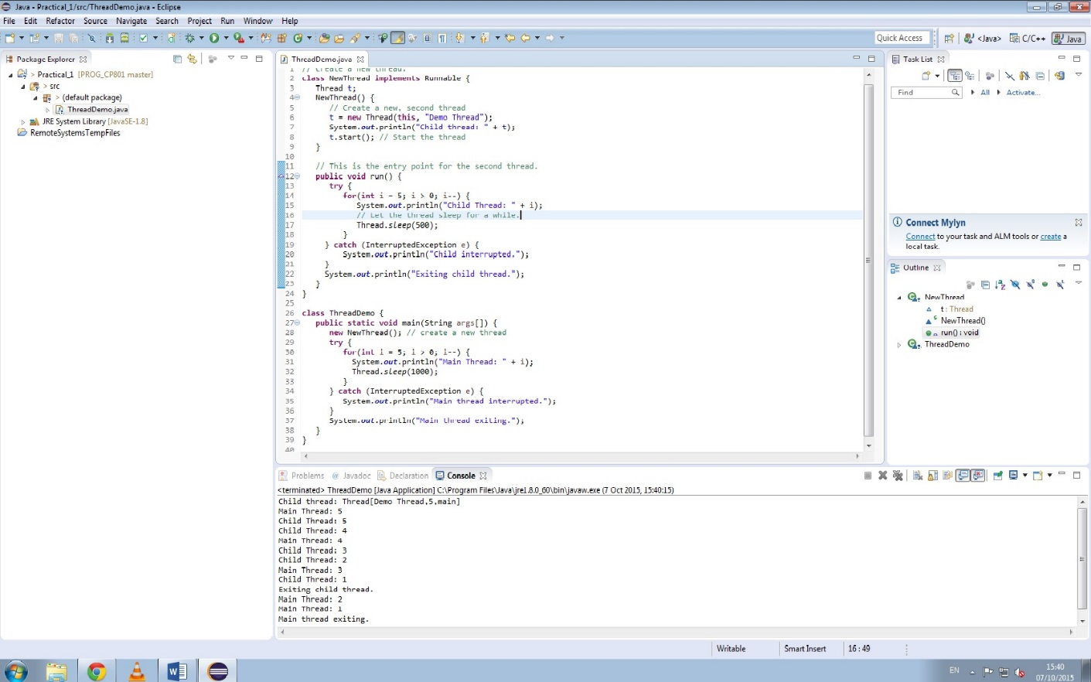

In this exercise the class NewThread is created by implementing the Runable Interface.

Exercise 2:

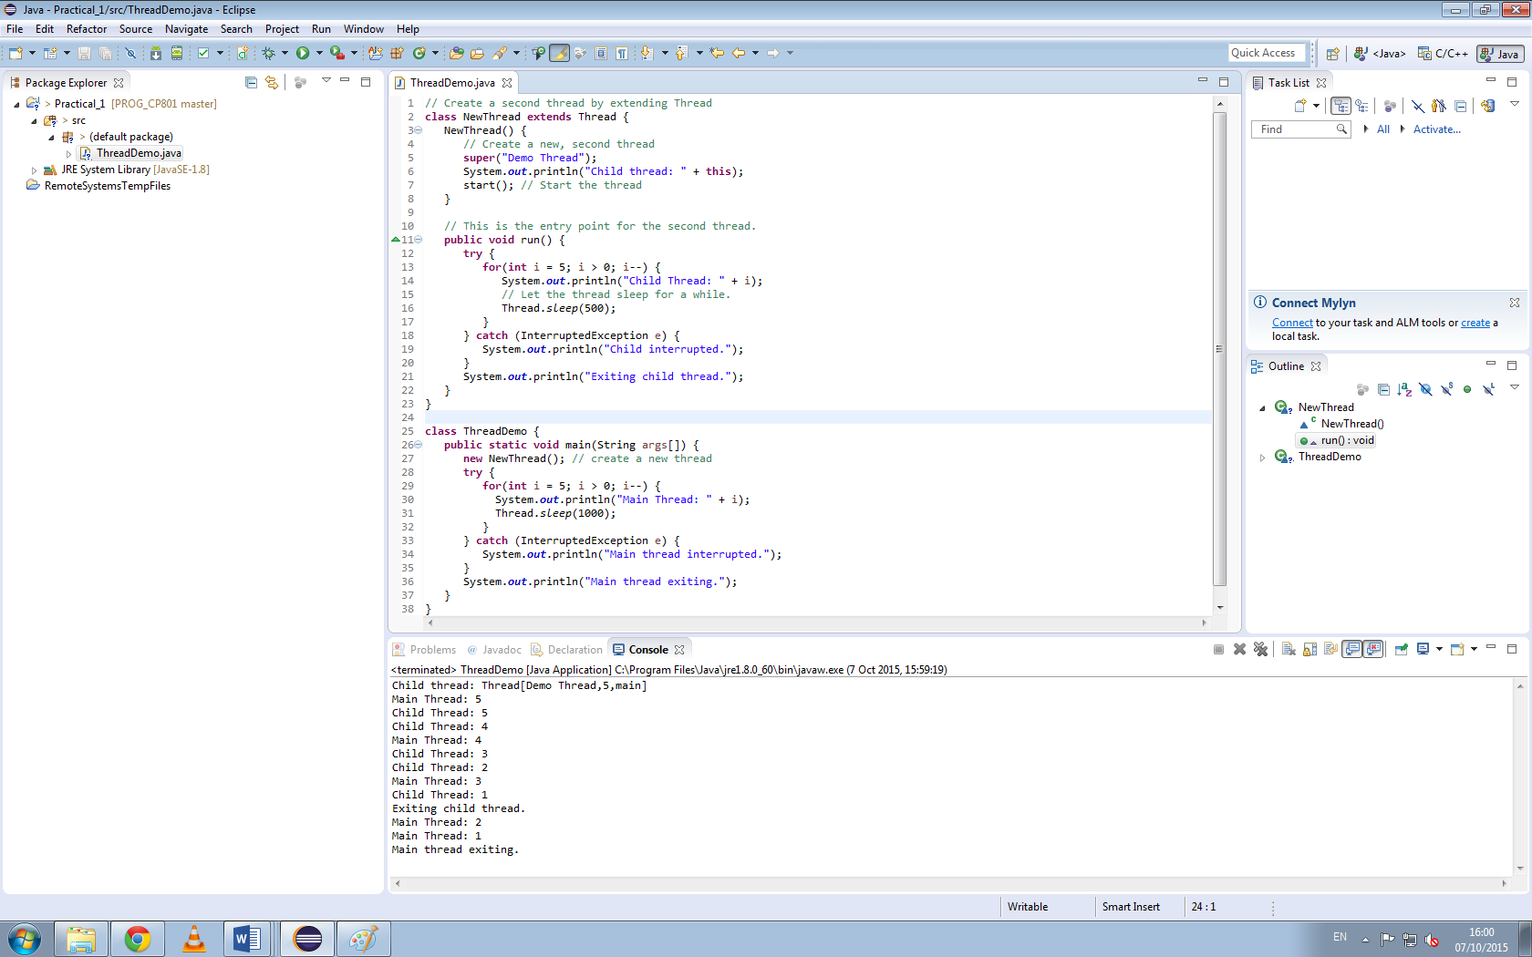

In this exercise the class NewThread is created by extending the Thread class and overriding the run() method .

Questions:

The new output is as follows:  
Child thread: Thread[Demo Thread,5,main]

Main Thread: 5

Child Thread: 5

Child Thread: 4

Main Thread: 4

Child Thread: 3

Child Thread: 2

Main Thread: 3

Child Thread: 1

Exiting child thread.

Main Thread: 2

Main Thread: 1

Main thread exiting.

public void start():   
This method starts the thread by invoking run().

public void run():   
This method is executed when the thread is started. The thread is stopped, when the run() method returns.   
Throws a InterruptedException when interrupted.

public final void setName(String name):  
This method sets the name variable in the class Thread.

public final void setPriority(int priority):  
This method set the priority for this thread.  
The smaller of the given priority or the max thread’s group priority is set as the priority.  
A SecurityException is thrown if the current thread cannot change the priority.  
A [IllegalArgumentException](http://docs.oracle.com/javase/7/docs/api/java/lang/IllegalArgumentException.html) is thrown if the given priority is not between MIN_PRIORITY and MAX_PRIORITY.

public final void setDaemon(boolean on):   
Marks this thread as a deamon thread or user thread.  
A SecurityException is thrown if the current thread cannot change this thread.  
A IllegalThreadStateException is thrown if the thread is already running.

public final void join(long millisec):  
Waits for this thread to finish for the given time in milliseconds.  
A IllegalArgumentException is thrown if millisec is negative.  
A InterruptedException if this thread has been interrupted by another thread.

public void interrupt():